### 

### Semester Two Examination, 2021

### Question/Answer booklet

# MATHEMATICS METHODS

**UNIT 3 & 4**

## Section Two:

## Calculator-assumed

|  |  |
| --- | --- |
| **Your Name:** |  |
| **Your Teacher’s Name:** |  |

## Time allowed for this section

Reading time before commencing work: ten minutes

Working time: one hundred minutes

## Materials required/recommended for this section

***To be provided by the supervisor***

This Question/Answer booklet

Formula sheet (retained from Section One)

***To be provided by the candidate***

Standard items: pens (blue/black preferred), pencils (including coloured), sharpener, correction fluid/tape, eraser, ruler, highlighters

Special items: drawing instruments, templates, notes on two unfolded sheets of A4 paper, and up to three calculators approved for use in this examination

## Important note to candidates

No other items may be taken into the examination room. It is **your** responsibility to ensure that you do not have any unauthorised material. If you have any unauthorised material with you, hand it to the supervisor **before** reading any further.

|  |  |  |  |  |  |
| --- | --- | --- | --- | --- | --- |
| Question | Marks | Max | Question | Marks | Max |
| 7 |  | 7 | 13 |  | 10 |
| 8 |  | 9 | 14 |  | 11 |
| 9 |  | 9 | 15 |  | 9 |
| 10 |  | 8 | 16 |  | 8 |
| 11 |  | 10 | 17 |  | 7 |
| 12 |  | 12 |  |  |  |

**Structure of this paper**

|  |  |  |  |  |  |
| --- | --- | --- | --- | --- | --- |
| Section | Number of questions available | Number of questions to be answered | Working time (minutes) | Marks available | Percentage of examination |
| Section One:  Calculator-free | 6 | 6 | 50 | 50 | 33 |
| Section Two:  Calculator-assumed | 11 | 11 | 100 | 100 | 67 |
|  |  |  |  | **Total** | 100 |

**Instructions to candidates**

1. The rules for the conduct of the Western Australian Certificate of Education ATAR course examinations are detailed in the *Year 12 Information Handbook 2019*. Sitting this examination implies that you agree to abide by these rules.
2. Write your answers in this Question/Answer booklet.
3. You must be careful to confine your answers to the specific questions asked and to follow any instructions that are specific to a particular question.
4. Additional pages for the use of planning your answer to a question or continuing your answer to a question have been provided at the end of this Question/Answer booklet. If you use the space to continue an answer, indicate in the original answer space where the answer is continued, i.e. give the page number.
5. **Show all your working clearly.**Your working should be in sufficient detail to allow your answers to be checked readily and for marks to be awarded for reasoning. Incorrect answers given without supporting reasoning cannot be allocated any marks. For any question or part question worth more than two marks, valid working or justification is required to receive full marks. If you repeat any question, ensure that you cancel the answer you do not wish to have marked.
6. It is recommended that you **do not use pencil**, except in diagrams.
7. The Formula sheet is **not** to be handed in with your Question/Answer booklet.

**Section One: Calculator-assumed (100 Marks)**

This section has **eleven** questions. Answer **all** questions. Write your answers in the spaces provided.

Spare pages are included at the end of this booklet. They can be used for planning your responses and/or as additional space if required to continue an answer.

● Planning: If you use the spare pages for planning, indicate this clearly at the top of the page.

● Continuing an answer: If you need to use the space to continue an answer, indicate in the original answer space where the answer is continued, i.e. give the page number. Fill in the number of the question that you are continuing to answer at the top of the page.

Working time: 100 minutes.

**Question 7 (7 marks)**

A projectile is fired upward from a $15.3 m$ cliff at a speed of $19.6 m/s$ and falls into a valley below. The acceleration $g$ due to Earth’s gravity is about $9.8 m/s^{2}$ downwards.

1. Given that $a(t) = –9.8 m/s^{2}$, determine an expression for $v(t)$ and use it to find the time at which the projectile reaches its maximum height. (2 marks)

|  |
| --- |
| **Solution** |
| $$v\left(t\right)=-9.8t+C, v\left(0\right)=C =19.6$$ $$v\left(t\right)=-9.8t+19.6$$ $$v(t)=0, t=2s$$ |
| **Specific** **Behaviours** |
| * States the expression for $v\left(t\right).$* Determines the correct time. |

1. Determine this maximum height of the projectile. (2 marks)

|  |
| --- |
| **Solution** |
| $$15.6+\int_{0}^{2}{-9.8t+19.6}=34.9m$$ |
| **Specific** **Behaviours** |
| * Sets up the correct integral. * Determines the correct height. (2 marks) |

1. Determine the **total distance** traveled over the time interval $0≤t≤3$. (3 marks)

|  |
| --- |
| **Solution** |
| (3 marks)  OR $$\int_{2}^{3}{-9.8t+19.6}=-4.9m$$ $$19.6+4.9=24.5m$$ |
| **Specific** **Behaviours** |
| * Determines the distance between 2 and 3 seconds * Adds the distance to19.6m * Determines the total distance |

**Question 8** **(9 marks)**

The table below summarises census information about the number of children in the households of an Australian town.

|  |  |  |  |  |  |
| --- | --- | --- | --- | --- | --- |
| Number of children | 0 | 1 | 2 | 3 | 4 or more |
| Percentage of households | 23 | 32 | 35 | 7 | 3 |

A random sample of 20 households is selected from this town.

1. State the distribution and determine the probability that the sample will contain:
   1. 3 households only with no children. (2 marks)

|  |
| --- |
| **Solution** |
| $$X\sim the number of household with no childen$$ $$X \sim Bin(20. 0.23)$$ $$P(X=3)=binomialPDf (3,20, 0.23)=0.163091$$ |
| **Specific** **Behaviours** |
| * States binomial distribution with correct parameters * Determines the correct probability |

* 1. more than half the households, with at least 2 children. (3 marks)

|  |
| --- |
| **Solution** |
| $$Y\sim at least 2 children household$$ $$Y\sim B(20,0.45)$$ $$P(Y>10)= 1-P(Y≤10)$$ |
| **Specific Behaviours** |
| * States binomial distribution with correct parameters * Recognises the correct probability expression $P(Y>10)$* Determines the correct probability |

A new random sample of $n$ households is selected from this town. The probability that this new sample contains a household with 4 or more children is more than 10%.

1. Determine the smallest value of $n$ . (4 marks)

|  |
| --- |
| **Solution** |
|  |
| **Specific Behaviours** |
| * States binomial distribution with correct parameters * Checks probability for $n=4$* Checks probability for $n=3$* Concludes $n=4$ |

**Question 9 (9 marks)**

When refuelling the car, the rate of flow of petrol into the tank is given by

$\frac{dV}{dt}\text{= }\text{9}{\text{e}}^{-\left(t+2\right)}\left(8-t\right)$ for $0≤t≤8$,

where $V$ is the litres of petrol in the tank at time $t$ in minutes. Initially the tank has two litres of petrol.

(a)

1. Determine the ***exact*** initial rate of flow of petrol into the tank. (1 mark)

|  |
| --- |
| **Solution** |
|  |
| **Specific behaviours** |
| P States correct value |

1. Determine the value of $t$ for which $\frac{dV}{dt}\text{=}\text{0}$. (1 mark)

|  |
| --- |
| **Solution** |
|  |
| **Specific behaviours** |
| P States correct value |

1. Determine the time, to the nearest second, when the rate is 1 litre per minute. (2 marks)

|  |
| --- |
| **Solution** |
| $$t=1 minutes 59 seconds$$ |
| **Specific behaviours** |
| PP states to nearest second (do not accept decimal minutes) |

(b) Determine the amount of petrol in the tank, to one decimal place, when $t=8$. (3 marks)

|  |
| --- |
| **Solution** |
| $$V=10.5L$$ |
| **Specific behaviours** |
| P States the correct definite integral  P Adds initial amount of petrol  P States correct value to one decimal place |

(c) Determine the time, **to the nearest second**, when there are 10 litres of petrol in the tank. (2 marks)

|  |
| --- |
| **Solution** |
| 2 minutes 22 seconds |
| **Specific behaviours** |
| P states the correct definite integral  P states to nearest second (do not accept decimal minutes) |

**Question 10 (8 marks)**

# The volume, $V{cm}^{3}$, of a plastic bottle is given by $V=πr^{2}h+\frac{2}{3}πr^{3}$, where $h$ cm is the height and $r$ cm is the radius of its cap.

1. Given that $h=3 cm$, what is the approximate increase in volume when the radius expands by $p cm$ from $2 cm$? Use a calculus method to find your answer. (4 marks)

|  |
| --- |
| **Solution** |
| $$δV≈\frac{dV}{dr}×δr≈\left(2πr^{2}+6πr\right)×δr \\ At r=2 cm, δr=p cm \\ δV≈\left(2π×2^{2}+6π×2\right)×p = 20πp {cm}^{3}$$ |
| **Specific behaviours** |
| P Determines $\frac{dV}{dr}$ P Determines an expression for $δV$ in terms of $r$ PSubstitutes the correct $δr$ PDetermines the correct $δV$ |

1. If $h=6 cm$ and $r=4 cm$, use calculus to find the approximate percentage change, to one decimal place, in the volume when the radius increases by $q \%.$ (4 marks)

|  |
| --- |
| **Solution** |
| $$\frac{δV}{V}≈\frac{dV}{dr}×\frac{δr}{V}$$ $$=\left(2πr^{2}+12πr\right)×\frac{δr}{6πr^{2}+\frac{2}{3}πr^{3}}$$ $$= \frac{3(r+6)}{(r+9)}×\frac{δr}{r}$$ $$At r=4 cm, \frac{δr}{r}=q\%$$ $$\frac{δV}{V}≈\frac{3\left(4+6\right)}{4+9}×q= 2.3q\%$$ |
| **Specific behaviours** |
| P Uses incremental formula  P Determines an expression for $\frac{δV}{V}$ in terms of $r$ PSubstitutes correct expression for $\frac{δr}{r}$ P Simplifies and states correct percentage change |

**Question 11** **(10 marks)**

An aircraft designer is trailing a new wing shape with a cross section at a certain point enclosed by the function

$$y=-{k(x}^{2}-0.01)ln(x)$$

where $k$ is a positive constant, together with an interval of the $x$-axis from $x=a$ to .

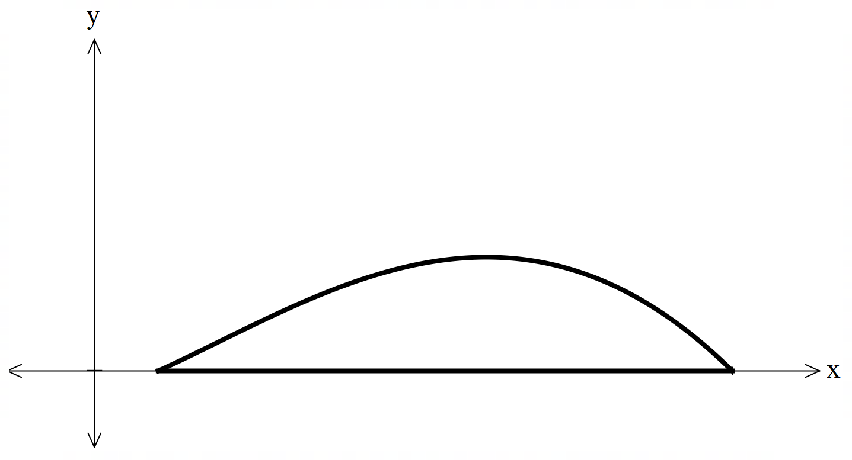

1. Determine the values of $a$ and $b$ (given that $a<b$). (2 marks)

|  |
| --- |
| **Solution** |
| $$-{k(x}^{2}-0.01)ln(x)=0$$ $x^{2}-0.01=0$ or $\ln\left(x\right)=0$ $x=0.1$ or $x=1$ $a=0.1$ and $b=1$ |
| **Specific behaviours** |
| P equates function to 0  P states both correct values |

1. Determine the value of $c$ (to 3 decimal places) above which the highest point of the top edge of the cross section occurs. (3 marks)

|  |
| --- |
| **Solution** |
| $$\frac{dy}{dx}=-k2x\ln\left(x\right)-k\left(x^{2}-0.01\right)×\frac{1}{x}=0$$ $$x=0.61461$$ $$c=0.615$$ |
| **Specific behaviours** |
| P writes correct derivative  P equates derivative to 0  P states correct value of $c$ to 3 decimal places |

1. Find, to 3 decimal places, the value of $k$ such that the maximum height of the cross section is 0.15 units. (3 marks)

|  |
| --- |
| **Solution** |
| $$0.15=-{k(0.615}^{2}-0.01)ln⁡(0.615)$$ $$k=0.838$$ |
| **Specific behaviours** |
| P substitutes value of c from part (b) into function  P equates to 0.15  P states correct value of $k$ to 3 decimal places |

1. Determine, to 3 decimal places, the area of the cross section for the value of $k$ determined in part (c). (2 marks)

|  |
| --- |
| **Solution** |
| $$\int_{0.1}^{1}{-0.838}\left(x^{2}-0.01\right)\ln{(x)}dx=0.087$$ |
| **Specific behaviours** |
| P writes integral using limits from part (a) and $k$-value from part (c)  P states correct value for area |

**Question 12 (12 marks)**

Two electrical engineering companies produce light globes – one company produces type A and the other produces type B. Both types are normally distributed. A light globe is considered premium if it has a lifespan longer than 850 hours.

1. The company producing type A globes claims that their product has a mean lifespan of 818 hours and a standard deviation of 112 hours.
   1. What is the probability of a type A globe being premium? (2 marks)

|  |
| --- |
| **Solution** |
| $$A\sim N\left(818,{112}^{2}\right)$$ $$P\left(A>850\right)=0.3875$$ |
| **Specific** **Behaviours** |
| * Uses the correct probability statement * Determines the correct probability |

* 1. What is the probability of a type A globe being premium, given that its lifespan exceeds 800 hours? (2 marks)

|  |
| --- |
| **Solution** |
|  |
| **Specific** **Behaviours** |
| * Uses the conditional probability formula * Determines the correct probability |

* 1. What lifespan is exceeded by 90% of all type A globes produced? (2 marks)

|  |
| --- |
| **Solution** |
| $$P\left(A>k\right)=0.9$$ $$z=-1.2816$$ $$-1.2816=\frac{k-818}{112}$$ $$∴k=674.47$$ |
| **Specific** **Behaviours** |
| * Determines the z-score * Uses the z-score to determine the value of |

* 1. If the company selects 50 type A batteries one at a time, find the probability that it takes a selection of eight batteries before six premium batteries are selected. (3 marks)

|  |
| --- |
| **Solution** |
| $$X\sim Bin(7, 0.3875)$$ $$P\left(X=5\right)×0.3875$$ $$=0.06883×0.3875$$ $$=0.02667$$ |
| **Specific** **Behaviours** |
| * Sets up a binomial distribution with correct parameters * Determines $P(X=5)$* Determines the correct probability |

1. The company producing type B light globes claims that 31% of their product has a lifespan over 860 hours, and 19% have a lifespan below 700 hours. Determine the mean and standard deviation for the type B light globes. (3 marks)

|  |
| --- |
| **Solution** |
| $$B\sim N(μ,σ^{2})$$ $$P\left(B>860\right)=0.31 z=0.4959$$ $$P\left(B<700\right)=0.19 z=-0.8779$$ $$0.4959=\frac{860-μ}{σ}$$ $$-0.8779=\frac{700-μ}{σ}$$ (CAS Simultaneous): $μ=802.25$ and $σ=116.47$ |
| **Specific** **Behaviours** |
| * Determines the z-scores for both probability statements * Sets up simultaneous equations to solve for the parameters * Determines the mean and standard deviation |

**Question 13 (10 marks)**

A discrete random variable $Y$ is defined by $P\left(Y=y\right)=a\log{(x-1)}$ for $x=6, 11$ and $21$

1. Determine the value of $a$. (3 marks)

|  |
| --- |
| **Solution** |
| $$a\log\left(5\right)+a\log\left(10\right)+a\log\left(20\right)=1$$ $$a\log{(5×10×20)}=1$$ $$a\log{1000}=1$$ $$a=\frac{1}{\log{1000}}=\frac{1}{3}$$ |
| **Specific** **Behaviours** |
| * Substitutes and sums the probabilities to 1 * Uses log laws to add the logs together * Determines the value of $a$ |

1. Determine $P\left(Y=21\right| Y>6)$ in exact form. (3 marks)

|  |
| --- |
| **Solution** |
|  |
| * **Specific** **Behaviours** |
| * Uses the conditional probability formula * Substitutes the correct numerator * Substitutes the correct denominator and leaves answer in exact form |

1. The expected value $E\left(Y\right)=\frac{38}{3}+m\log{n}$ where the constants $m$ and $n$ are prime numbers. Determine the values of $m$ and $n$. (4 marks)

|  |
| --- |
| **Solution** |
| $$E\left(Y\right)=6\left(\frac{1}{3}\log{5}\right)+11\left(\frac{1}{3}\log{10}\right)+21\left(\frac{1}{3}\log{20}\right)$$ $$=2\log{5}+\frac{11}{3}\log{10}+7\log{20}$$ $$=2\log{5}+\frac{11}{3}+7\log{20}$$ $$=2\log{5}+\frac{11}{3}+2\log{20}+5\log{20}$$ $$=2\log{100}+\frac{11}{3}+5\log{2}+5\log{10}$$ $$=4+5+\frac{11}{3}+5\log{2}$$ $$=\frac{38}{3}+5\log{2}$$ $∴m=5$ and $n=2$ |
| **Specific** **Behaviours** |
| * Expresses $E(Y)$ as the sum of logs * Simplifies and splits the $7\log{20}$ term * Combines logs and splits $5\log{20}$ term * Determines the values of $m$ and $n$ |

**Question 14 (11 marks)**

A company that manufactures professional photography drones uses a particular model of accelerometer that fails when it becomes too hot. The temperatures $T℃$ at which a randomly chosen accelerometer fails are normally distributed.

1. In preliminary laboratory tests, 97% of a random sample of accelerometers continued working at a temperature of at least $85℃$, but only 5% continued working at least $105℃$.
   1. Calculate the mean and standard deviation of the distribution

(4 marks)

|  |
| --- |
| **Solution** |
| $$\operatorname{Pr}\left(Z≥\frac{85-μ}{σ}\right)=0.97$$ $$\operatorname{Pr}\left(Z≥\frac{105-μ}{σ}\right)=0.05$$ $$\frac{85-μ}{σ}=-1.880794$$ $$\frac{105-μ}{σ}=1.6448536$$ CAS Solve    The mean and standard deviation are approximately 95.7 $℃$ and 5.6 $℃$ respectively. |
| **Specific behaviours** |
| * Forms an equation for the standard score of 85 $℃$* Forms an equation for the standard score of 105 $℃$* States the mean * States the standard deviation |

* 1. What proportion of accelerometers will operate at least at $100℃$ (2 marks)

|  |
| --- |
| **Solution** |
| $$\operatorname{Pr}\left(T<100\right)=Pr\left(Z≤\frac{100-95.6692}{5.6727}\right)$$ CAS Solve $$Pr\left(T≤100\right)=0.7774$$ $$∴Pr\left(T≥100\right)=1-0.7774=0.2226$$  22.26% of accelerometers will operate at $100℃$ |
| **Specific behaviours** |
| * States the proportion that will operate at or below $100℃$* States the proportion that will operate at or above $100℃$ |
|  |

1. During the process of thorough testing, the manufacturer took repeated samples and one sample of 300 accelerometers revealed that 51 continued to function at $100℃$
   1. State the approximate distribution of the sample proportions and justify your choice. (3 marks)

|  |
| --- |
| **Solution** |
| $$\hat{p}\sim N\left(0.17,\frac{0.17×0.83}{300}\right)$$ $$\hat{p}\sim N(0.17,{0.0216871}^{2})$$ A normal approximation model is appropriate as the value of *n* is large enough for the distribution to approach normality. |
| **Specific behaviours** |
| * Indicates Normal distribution * Calculates the correct mean and standard deviation (or variance) * Correctly justifies why the normal distribution can be used |

* 1. Provide a 99% confidence interval for the proportion of accelerometers that can function at a temperature of at least $100℃$ (2 marks)

|  |
| --- |
| **Solution** |
| A 99% confidence interval is [0.1141,0.2259] |
| **Specific behaviours** |
| * Correct upper bound * Correct lower bound |

**Question 15 (9 marks)**

An engineering project requires an original part $PBQ$ that is conical in shape. At a later stage of the project, a smaller cone $PAQ$ will be extracted from the original such that $AP = AB = AQ$. We will use the letter $a$ to represent the three equal lengths $AQ, AB$ and $AP$. We will use the letter $r$ to represent the radii $OP$ and $OQ$ of the circular section of the cone. We will use the letter $h$ to represent the altitude OB of the original cone. Both angles $∠OAP$ and $∠OAQ$ have a magnitude $θ$. It is advised that you label the diagram accordingly.

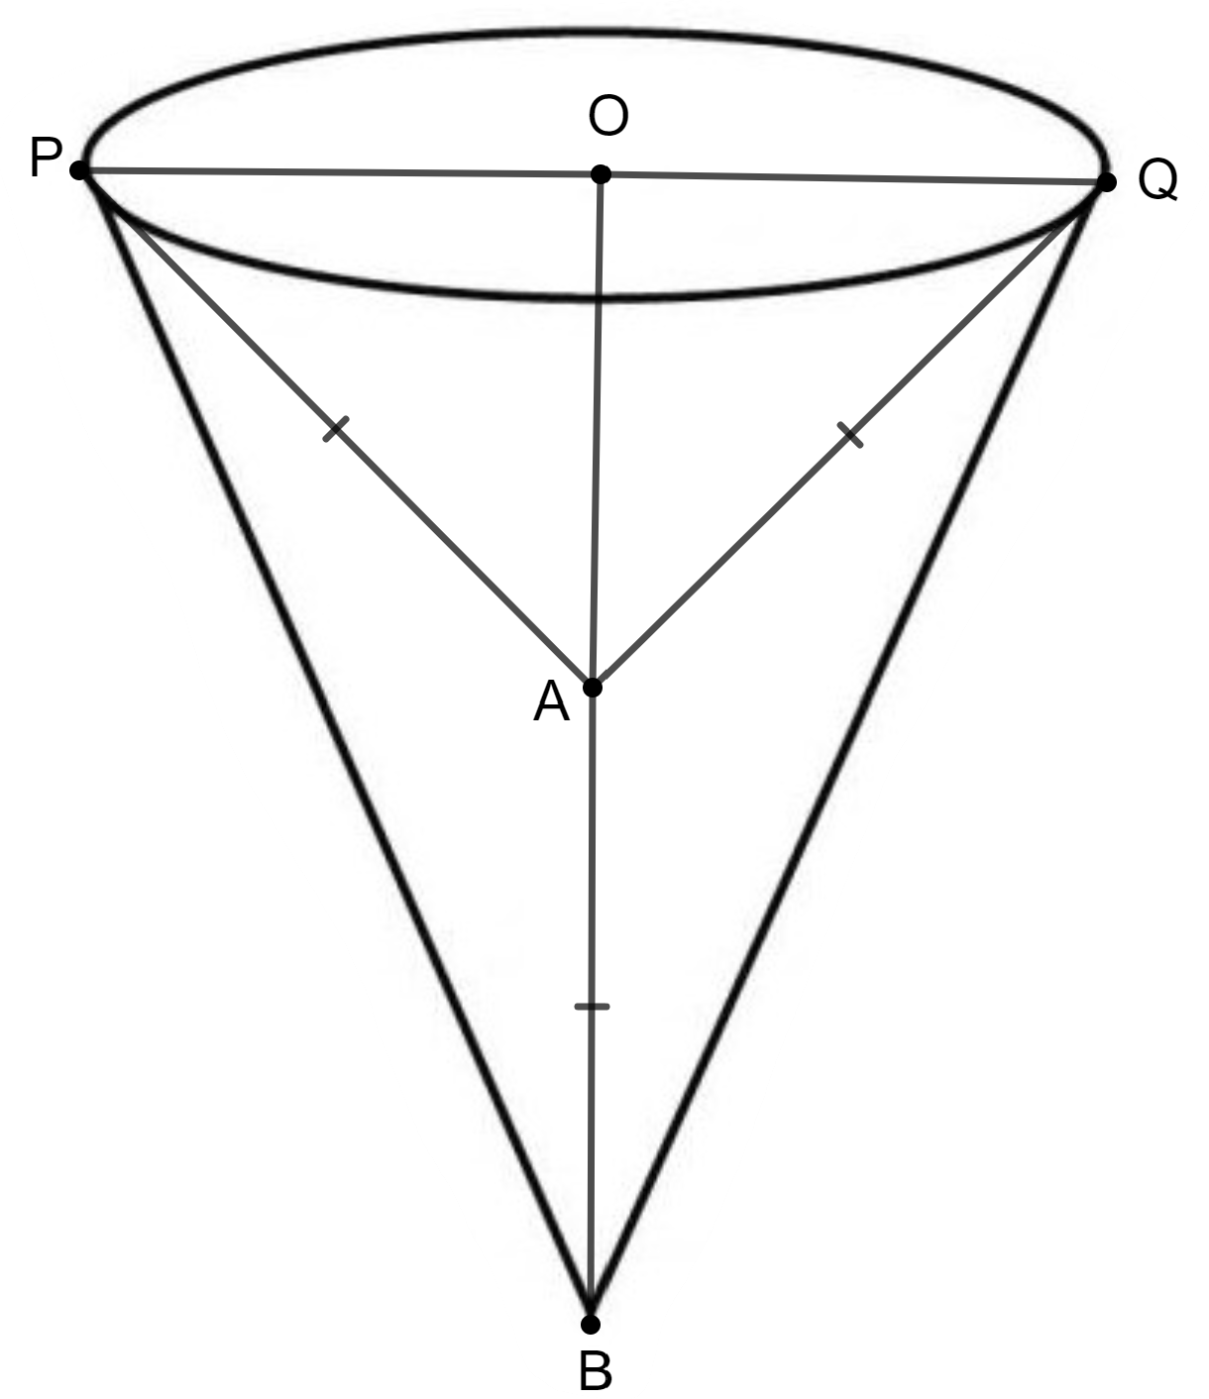

1. Find $h$, the altitude of the original cone, in terms of $a$ and $θ$. (1 mark)

|  |
| --- |
| **Solution** |
| $$h=a+a cosθ$$ |
| **Specific behaviours** |
| * States $h$ in terms of $a$ and $θ$ |

1. Find $r$, the radius of the circular section of the cone, in terms of $a$ and $θ$. (1 mark)

|  |
| --- |
| **Solution** |
| $$r=a sinθ$$ |
| **Specific behaviours** |
| * States $h$ in terms of $a$ and $θ$ |

The volume of the cone is given by $V=\frac{1}{3}πr^{2}h$.

1. Use the results from (a) and (b) to show that (2 marks)

$$V=\frac{1}{3}πa^{3}\sin^{2}{θ\left(1+\cos{θ}\right)}$$

|  |
| --- |
| **Solution** |
| $$V=\frac{1}{3}πr^{2}h=\frac{1}{3}π(a^{2}\sin^{2}θ)(a+a cosθ)$$ $$=\frac{1}{3}π\left(a^{3}\sin^{2}θ\right)+\frac{1}{3}π\left(a^{3}\sin^{2}θ\right)(cosθ)$$ $$=\frac{1}{3}πa^{3}\sin^{2}θ(1+cosθ)$$ |
| **Specific behaviours** |
| * Substitutes results from (a) and (b) into the volume formula * Factors out $\frac{1}{3}π\left(a^{3}\sin^{2}θ\right)$ |

1. Given that $a$ is a constant, find $\frac{dV}{dθ}$ and hence find the value(s) of $θ$ for which the volume is maximised.

(5 marks)

|  |
| --- |
| **Solution** |
| $$\frac{dV}{dθ}=\frac{1}{3}πa^{3}(\sin^{2}θ(-sinθ) +\left(1+cosθ\right)2sinθcosθ)$$ $$\frac{dV}{dθ}=\frac{1}{3}πa^{3}\left({-sin}^{3}θ +2sinθcosθ\left(1+cosθ\right)\right)$$ $\frac{dV}{dθ}=0$ for maximum or minimum volume $$\frac{1}{3}πa^{3}\left({-sin}^{3}θ +2sinθcosθ\left(1+cosθ\right)\right)=0$$ $${-sin}^{3}θ+2sinθcosθ\left(1+cosθ\right)=0$$ $$2sinθcosθ\left(1+cosθ\right)=\sin^{3}θ$$ Since $sinθ≠0$, $2cosθ\left(1+cosθ\right)=\sin^{2}θ$ $$2cosθ\left(1+cosθ\right)={1-cos}^{2}θ$$ $$2cosθ+2\cos^{2}θ={1-cos}^{2}θ$$ $$3\cos^{2}θ+2cosθ-1=0$$ $$(3cosθ-1)(cosθ+1)=0$$ $cosθ=\frac{1}{3}$ or $cosθ=-1$ $θ={70.5}^{o}$ (Reject ${180}^{o}$ and ${289.5}^{o}$)  If used CAS |
| **Specific behaviours** |
| * Shows use of product rule * Correct first derivative * Equates $\frac{dV}{dθ}$ to zero * Rejects ${180}^{o}$ and ${289.5}^{o}$* States the required angle of ${70.5}^{o}$ |

**Question 16 (8 marks)**

5000 boxes of a certain kind of cereal are stored in a warehouse. The cereal manufacturer wishes to estimate the proportion of boxes in the warehouse that weigh less than the 300g stated on the box. The manufacturer asks a warehouse employee to sample and weigh 200 cereal boxes. The boxes are stored in the warehouse on 50 numbered shelves (with 100 boxes arranged in a line on each shelf).

1. Briefly describe a suitable method for selecting the sample of 200 boxes. (2 marks)

|  |
| --- |
| **Solution** |
| The employee could use a random number generator.  E.g. to select each box they could first generate a random number from 1-50 to select the shelf, and then generate a random number from 1-100 to select the box from that shelf. |
| **Specific behaviours** |
| P indicates some random mechanism  P indicates that the boxes are selected accordingly |

The warehouse employee finds that 38 of the 200 selected boxes weigh less than 300g.

1. Determine the sample proportion of underweight cereal boxes, and thus **show** that a 90% confidence interval for the proportion of underweight boxes (to 3 decimal places) is $(0.144, 0.236)$. (4 marks)

|  |
| --- |
| **Solution** |
| $$\hat{p}=\frac{38}{200}=0.19$$ $90\% confidence interval =\left(0.19-1.645×\sqrt{\frac{0.19×0.81}{200}},0.19+1.645×\sqrt{\frac{0.19×0.81}{200}}\right)$ $$=(0.19-0.046, 0.19+0.046) \\ =\left(0.144, 0.236\right)$$ |
| **Specific behaviours** |
| P states the correct sample proportion  P uses the correct value for the standard error  P uses the correct $z$-value interval  P shows correct method for calculating the confidence interval |

1. The manufacturer later consults factory records to conduct a census of the weights of all 5000 boxes in the warehouse, and finds that the proportion of underweight boxes is $0.2528$ (assume that this is the correct proportion). The manufacturer accuses the employee of being careless in their measurements or calculations. Is this accusation justified? Briefly explain your answer. (2 marks)

|  |
| --- |
| **Solution** |
| No. Only 90% of 90% confidence intervals are expected to contain the true proportion. It is possible that the survey and calculation by the warehouse employee was performed appropriately, but happened to yield one of the 10% of confidence intervals that do not contain the true proportion. |
| **Specific behaviours** |
| P answers ‘No’ with a reference to part (b) - MUST make reference to the confidence interval calculated in part (b)  P justifies answer by saying that only 90% of intervals are expected to contain the true proportion OR compares the overlap with a new 90% confidence interval using 0.2528 |

**Question 17 (7 marks)**

Consider a lifeguard at a circular pool, at position A, with diameter of $60 m$. He must reach someone who is drowning on the exact opposite side of the pool, at position C. The lifeguard is considering taking a two-stage route, first swimming at angle $θ$ with a speed $1 m/s$ to position B and then leaving the pool and running around the pool at speed $3m/s.$

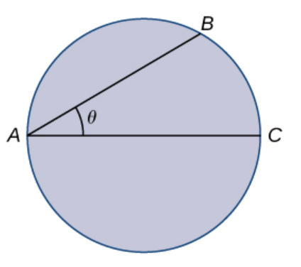

**O**

1. Determine the function $T\left(θ\right)$ as the total amount of time it takes to reach the drowning person, in terms of the swim angle $θ$ (radians). Hint: $Angle BOC=2θ$.

(3 marks)

|  |
| --- |
| **Solutions** |
| $AB=60 cosθ$, $$Arc length BC=30\left(2θ\right)=60θ$$ $$T\left(θ\right)=\frac{60θ}{3}+\frac{60 cosθ}{1}=20θ+60cosθ$$ |
| **Behaviour** |
| * Determines the correct expression for AB. * Determines the correct expression for arc length BC. * Determines the correct expression for $T\left(θ\right)$. No need to simplify. |

1. Using Calculus, justify whether this two-stage route will **minimise** the time the lifeguard takes to reach the drowning person. If not, determine the route that will.

(4 marks)

|  |
| --- |
| **Solutions** |
| $$T^{'}\left(θ\right)=20-60sinθ=0, θ≈0.34 radians$$ $T^{''}\left(θ\right)=-60\cos\left(0.34\right)<0$, $local maximum$ $$Hence, the two stage route will not give mimimum time.$$ $T\left(0\right)=60 s, T\left(\frac{π}{2}\right)=31.41593$ s  Therefore, the fastest route is to run around the pool directly. |
| **Behaviour** |
| * Equates $T^{'}\left(θ\right)$ to 0 and solve for $θ$ in radians. * Uses 2nd derivative to show it is a local max and hence not the optimal route. * Calculates $T(0)$ and $T\left(\frac{π}{2}\right)$. * States the optimal route is to run around the pool. |

Additional working space

Question number: _______

Additional working space

Question number: ________

Additional working space

Question number: ________